- go to Course Evaluations (in myOxy Gateway or oxy.evaluationkit.com)
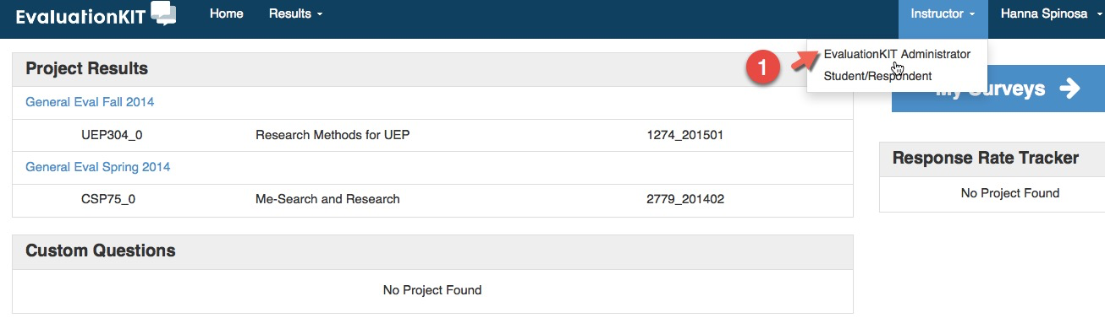
You can click on different roles- instructor or administrator.
When you click on "Instructor" you will only see your courses. Click "Administrator" to see the department chairs view.

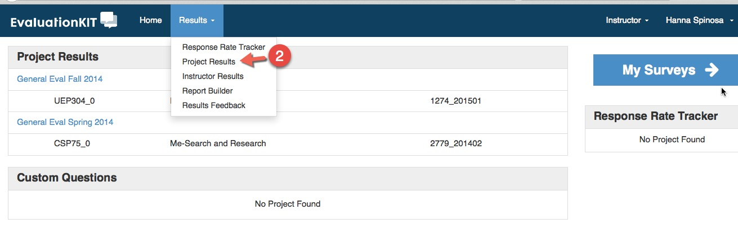
Click on Results and click on Project Results to see all the terms listed. These projects will be listed as type and term: e.g. "GENERAL FALL 2014" or "LAB SPRING 2013"

- Once you select a project, you can search by the course or instructor
- To find a specific instructor you can use the search parameter
- The columns also will allow you to sort quickly within the project (alphabetizing by instructor, course id, etc.)
- You can view the reports, reports with the comments, download individual data, etc.
